WEEK 2 - INTERNSHIP REPORT
Advanced Data Visualization & Storytelling
Project: Customer Churn Analysis and Prediction Using Python
Submitted By
ANJALI UMESH

Summary
This report presents an advanced visualization and data storytelling analysis of the IBM Telco Customer Churn dataset. The objective is to explore patterns associated with customer churn through visualizations that compare contract types, payment methods, internet services, customer tenure and monthly charges. Python libraries including Pandas, Matplotlib, Seaborn and Plotly were used to create the visualizations. The analysis indicates that month-to-month contracts and electronic-check payments are associated with higher churn rates. Customers who churned also had higher average monthly charges and shorter average tenure than customers who stayed. These findings can help a telecommunications business identify customer groups that may benefit from improved onboarding, service support and retention offers.

Introduction and Objectives
Customer churn occurs when customers discontinue a service. Understanding the patterns associated with churn can help a business improve customer retention and service experience. This task builds on the Week 1 data cleaning and exploratory analysis by using more advanced visualizations and explaining the insights in a business context.
- Compare churn rates across contract types and payment methods.
- Explore the combined relationship between contract type and internet service.
- Visualize the relationship between customer tenure, monthly charges and churn.
- Compare the distribution of monthly charges for customers who stayed and those who left.
- Translate the observed patterns into practical business recommendations.

Dataset and Tools
The analysis uses the cleaned IBM Telco Customer Churn dataset from Week 1. It contains 7,043 customer records and 21 columns, including customer tenure, monthly charges, contract type, internet service, payment method and churn status. The dataset was loaded into Google Colab from the Week 1 GitHub repository.
Tools and libraries: Python, Pandas, NumPy, Matplotlib, Seaborn, Plotly and Google Colab.

Advanced Visualizations and Interpretation

i) Customer Churn by Contract Type
A grouped count plot was used to compare customers who stayed and customers who churned across month-to-month, one-year and two-year contracts.
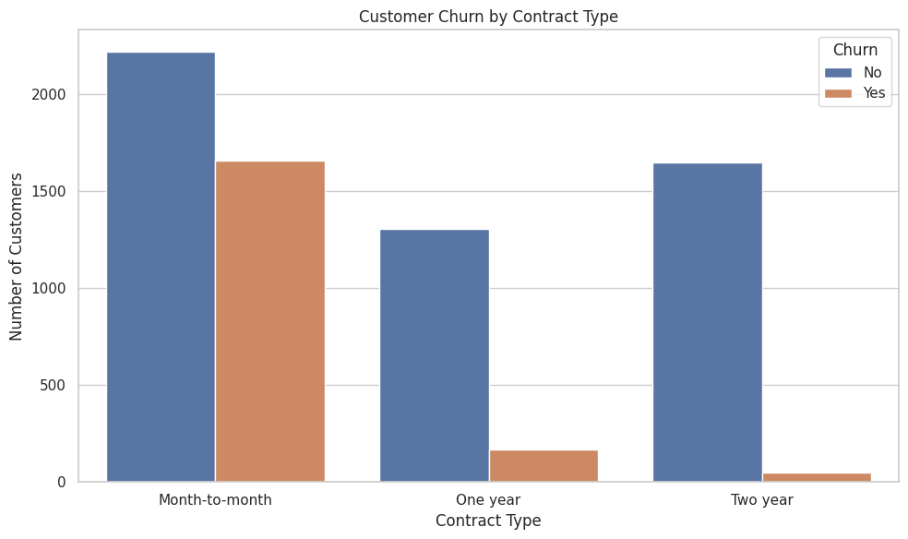

The calculated churn rates were 42.71% for month-to-month contracts, 11.27% for one-year contracts and 2.83% for two-year contracts. Month-to-month contracts therefore had the highest churn rate, while two-year contracts had the lowest. This suggests that longer contract commitments are associated with stronger customer retention.
The company could test loyalty benefits, contract upgrade offers and clear explanations of longer-term plan benefits. Offers should be designed carefully so that customers are not pressured into contracts that do not suit their needs.

ii) Customer Churn Percentage by Payment Method
A 100% stacked bar chart was created to compare the percentage of churned and retained customers within each payment method.
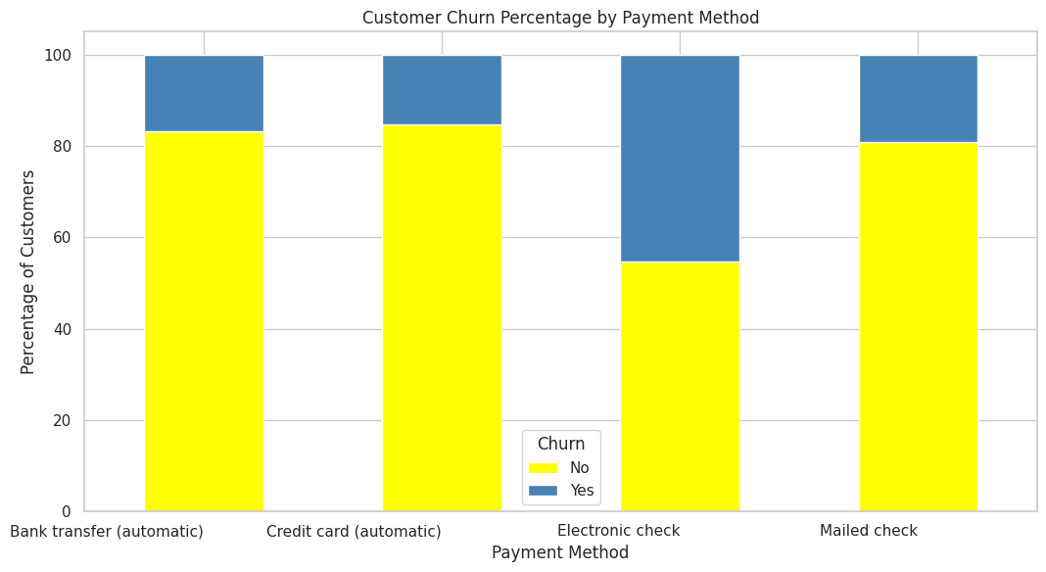
Electronic check users had the highest churn rate at 45.29%. The churn rates for mailed check, bank transfer (automatic) and credit card (automatic) were 19.11%, 16.71% and 15.24%, respectively. Electronic-check users therefore form a customer group worth investigating more closely.
The company could review the payment experience and communicate the convenience of automatic payment options. It could also investigate whether billing confusion, payment friction or other customer experience factors are related to this pattern.

iii) Churn Rate by Contract and Internet Service
An annotated heatmap was used to show churn rates for combinations of contract type and internet service. The cell values represent percentages.
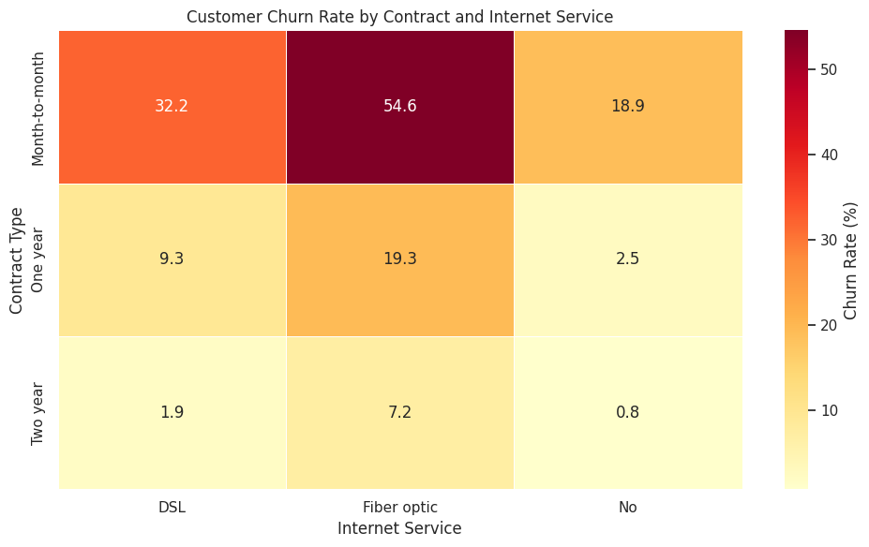

The highest rate was 54.61% for month-to-month customers using Fiber optic service. Month-to-month DSL customers had a churn rate of 32.22%, while month-to-month customers without internet service had a rate of 18.89%. Churn rates were lower for one-year and two-year contracts across the displayed internet service categories. The lowest displayed rate was 0.78% for two-year customers without internet service.
Retention efforts could prioritize month-to-month Fiber optic customers. The company could investigate pricing, service quality, support requests and customer expectations for this group before deciding on targeted improvements.

iv) Customer Tenure vs Monthly Charges
An interactive Plotly scatter plot compared customer tenure in months with monthly charges. Points were coloured by churn status, and hover information included contract, internet service and payment method.
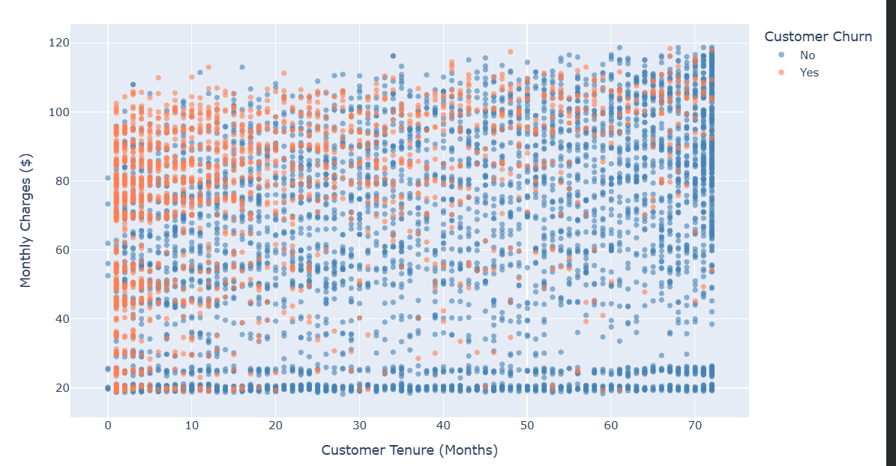
Churned customers were more concentrated among shorter-tenure customers, while customers who stayed were more widely represented at longer tenures. Churned and retained customers appeared across a range of monthly charge values, so monthly charges alone do not clearly separate the two groups. The average tenure values support the visual pattern: customers who churned had an average tenure of 17.98 months, compared with 37.57 months for customers who stayed.
The business could strengthen onboarding and early-stage customer support, follow up with new customers and identify service issues before customers decide to leave.

v) Distribution of Monthly Charges by Customer Churn
A violin plot was used to compare the distribution and density of monthly charges for customers who stayed and customers who churned. The inner quartile marks help show the spread of the values.
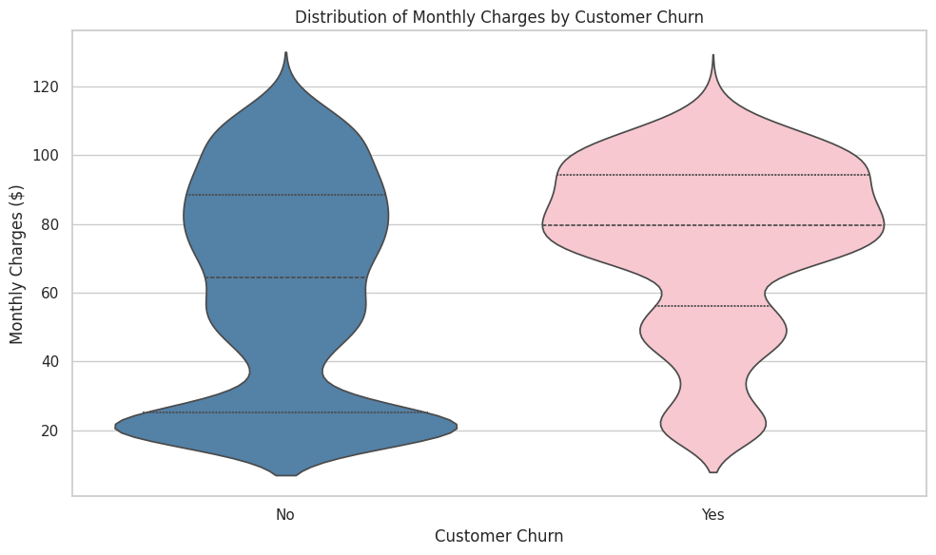

Customers who churned had a higher average monthly charge of $74.44 and a median of $79.65. Customers who stayed had an average monthly charge of $61.27 and a median of $64.43. The two distributions overlap, which means monthly charges alone cannot explain every customer's decision to churn.
The company could review whether higher-charge customers receive value that matches their expectations and consider suitable plan options or targeted support for customers who may be price-sensitive.

Consolidated Findings and Data Story
The visualizations tell a consistent story about customer churn. Contract type shows a strong difference in churn rates: month-to-month customers have a churn rate of 42.71%, compared with 2.83% for two-year customers. Payment method also shows a clear difference, with electronic-check users having a churn rate of 45.29%, substantially higher than the 15.24% rate among automatic credit-card users. The heatmap identifies month-to-month Fiber optic customers as the highest-churn combination at 54.61%. The tenure analysis adds another important dimension: customers who churned had an average tenure of 17.98 months, while customers who stayed had an average tenure of 37.57 months. Finally, churned customers had higher average monthly charges ($74.44) than retained customers ($61.27). Taken together, these patterns suggest that early customer experience, contract flexibility, payment experience and perceived value are useful areas for further investigation. These are associations in the dataset and do not establish that any one factor causes churn.

Strategic Recommendations
- Prioritize early retention: introduce helpful onboarding, service check-ins and support for new customers.
- Investigate month-to-month customers: understand why their churn rate is much higher and test suitable retention offers.
- Review the Fiber optic experience: examine pricing, service quality, complaints and support needs among month-to-month Fiber optic customers.
- Review electronic-check payment experience: investigate billing clarity and payment friction, and explain automatic payment options where appropriate.
- Review value for higher-charge customers: assess whether plans and service benefits meet customer expectations.
- Measure outcomes: evaluate retention campaigns using churn rate comparisons over time rather than relying only on customer counts.

Limitations
This analysis is based on one publicly available dataset and describes patterns within that dataset. The visualizations show associations and do not prove cause-and-effect relationships. Some groups may contain different numbers of customers, so percentages are more appropriate than raw counts when comparing churn across groups. The scatter plot contains many overlapping points, which can make individual observations difficult to distinguish. Further analysis, including statistical testing and predictive modelling, is needed before making operational decisions.

Conclusion
The Week 2 task applied advanced data visualization techniques to explore customer churn patterns and communicate findings through a data-driven narrative. Five visualizations highlighted differences by contract type, payment method, internet service, tenure and monthly charges. The findings suggest that newer customers, month-to-month customers, electronic-check users and month-to-month Fiber optic customers are important groups for further investigation. The analysis provides a foundation for the statistical analysis and machine learning tasks in the following internship weeks.The Python code and interactive notebook for this task are maintained separately in the Week 2 project folder in the GitHub repository. The notebook contains the dataset loading step, visualization code and calculations used to obtain the reported percentages and summaries.

